Promote Community – To Bring Rural and Urban Together
To showcase agriculture in our community by presenting an annual agricultural fair with quality exhibits, events, and educational activities.
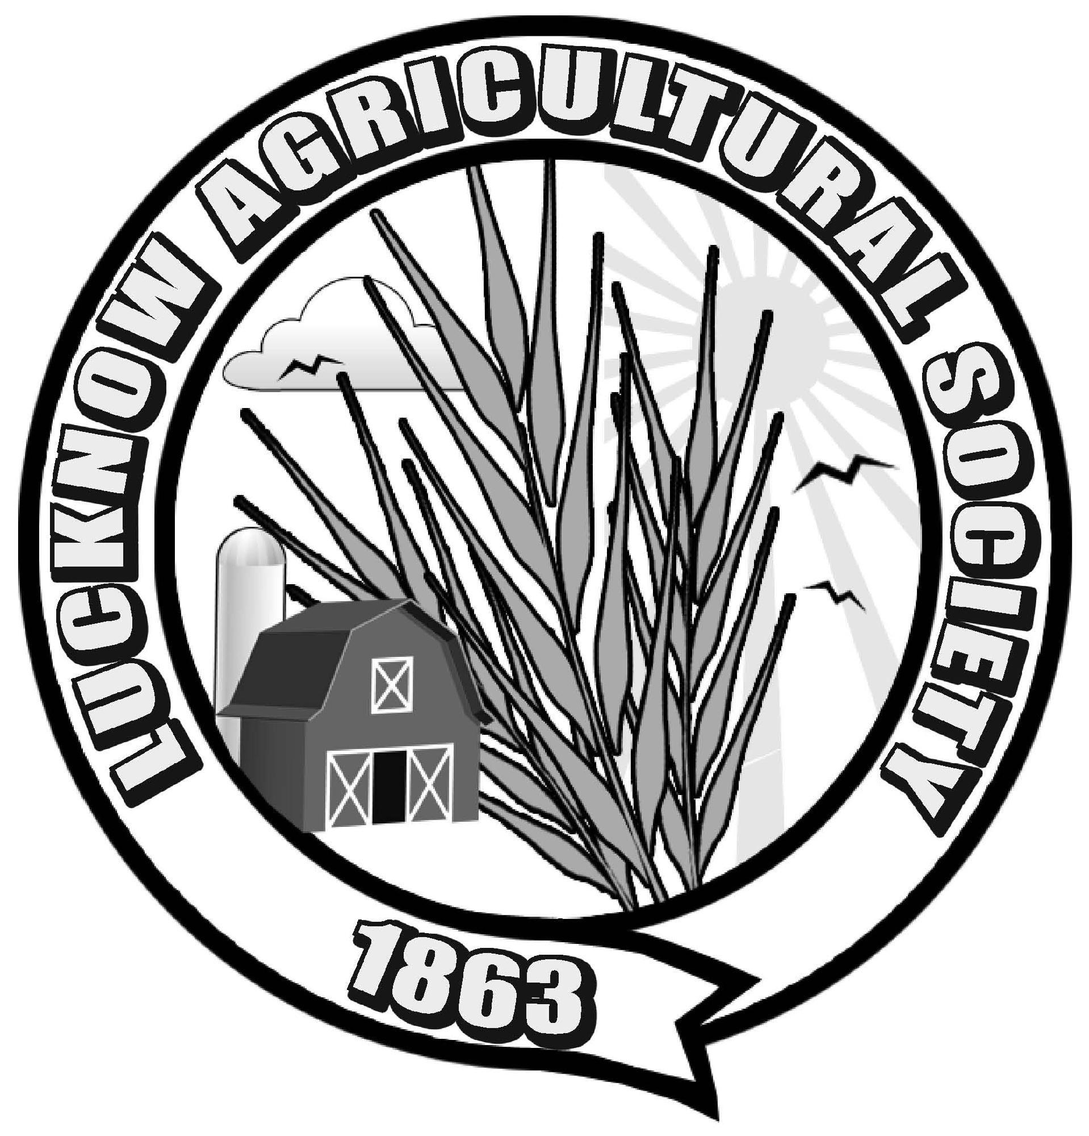

Lucknow Agricultural Society Lucknow Fall Fair
P.O. Box 178 3rd Weekend In September
Lucknow, ON. N0G 2H0

Dear Friend of the Fair,

We are very excited that the Lucknow Agricultural Society will be hosting the "Ambassador and Lil Ambassador of the Fair" competitions again this year. We would like to invite your organization to sponsor a senior contestant and have appreciated your support in the past.

This year, the competition will be held on Friday, September 16th at the Lucknow Arena.

For the Ambassador Competition, contestants (male or female) must be 17-22 years of age.

The registration deadline for contestants is July 1, 2016.

Please let us know if you are interested in sponsoring a contestant this year.
We have decided to do things a little differently this year and ask for a sponsorship fee. This fee will include the costs of a corsage and sash for your contestant and everything will be picked up and brought to the arena the night of the competition for you. We would appreciate receiving your entry form and sponsorship fee of $40 back by July 1, 2016.

If you need any information, or help finding a contestant, please don't hesitate to contact us. Even if you are not able to provide your own contestant, please let us know if you are still willing to be a sponsor and we will do our best to find a contestant for you. Thank you for your consideration!

Sincerely,

Ambassador of the Fair Committee
Lucknow Agricultural Society

Amanda Scott 519-440-2986; amascott630@gmail.com

