Promote Community – To Bring Rural and Urban Together
To showcase agriculture in our community by presenting an annual agricultural fair with quality exhibits, events, and educational activities.
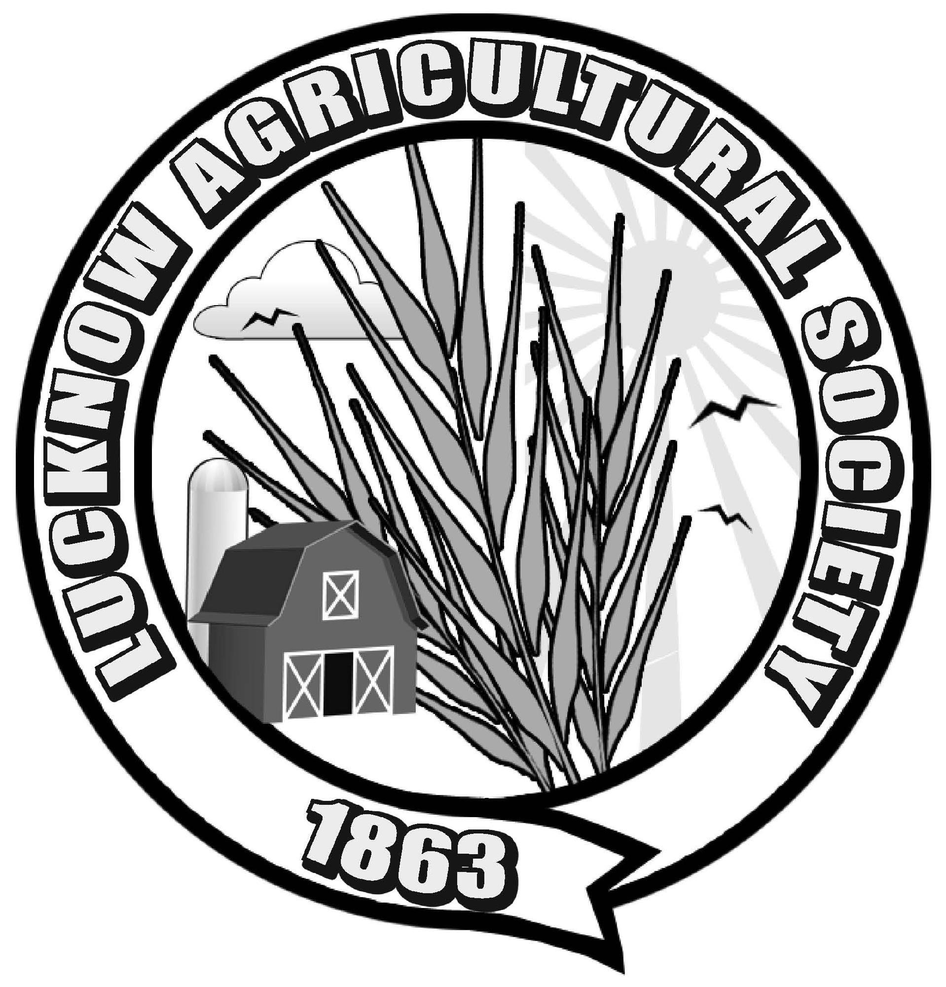

Lucknow Agricultural Society Lucknow Fall Fair
P.O. Box 178 3rd Weekend In September
Lucknow, ON. N0G 2H0

Lucknow Fall Fair Sr. Ambassador Competition 2016

Name of your Organization/Business: __________________________________________

We would like to sponsor a contestant this year: YES NO

We will be providing our own contestant: YES NO
IF YES Contestant Information:
Name: _____________________________________________________

Phone: _____________________________________________________

Address: ___________________________________________________

Email: _____________________________________________________

Organization Representative Contact Information

Name: _____________________________________________________________

Title (president/owner/etc): ____________________________________________

Phone: _____________________________________________________________

Address: ____________________________________________________________

Email: ______________________________________________________________

Sponsorship Fee Enclosed ($40): YES NO
*Please make cheques payable to Lucknow Agricultural Society

We wish to support the ambassador competition in another way: YES NO
If Yes: A donation to the gift bags the night of the competition ◻
or a monetary donation to the competition ◻

Please return this form by June 1, 2015 to:
Amanda Scott 519-440-2986; amascott630@gmail.com

